**Lesson 2-Buzzer play music**

****1.Learning goals:****

This lesson learns to use graphical programming to let the buzzer of the micro:bit play music.

****2.Search for blocks:****

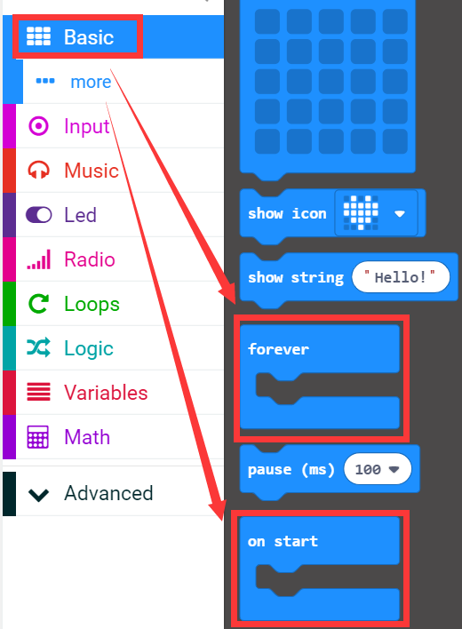

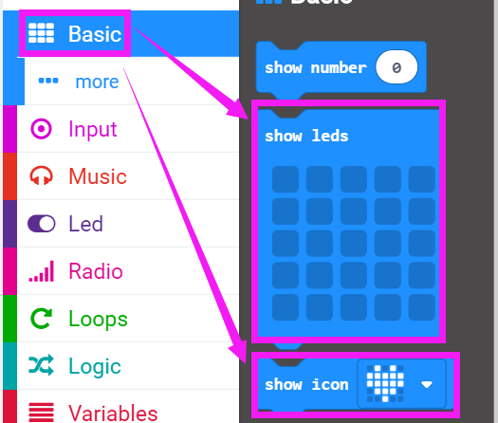

****3.Combine blocks:****

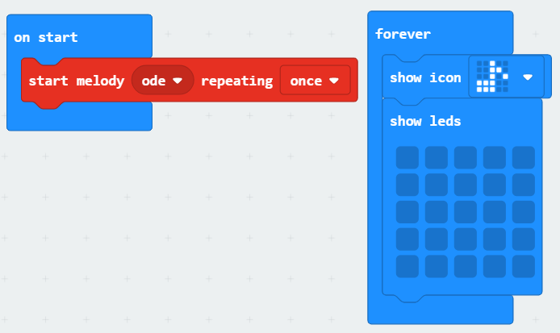

**4.Download programming**

After the program is downloaded. We can see that a note will flash on the dot matrix and the buzzer will play the ode once. As shown in figure.

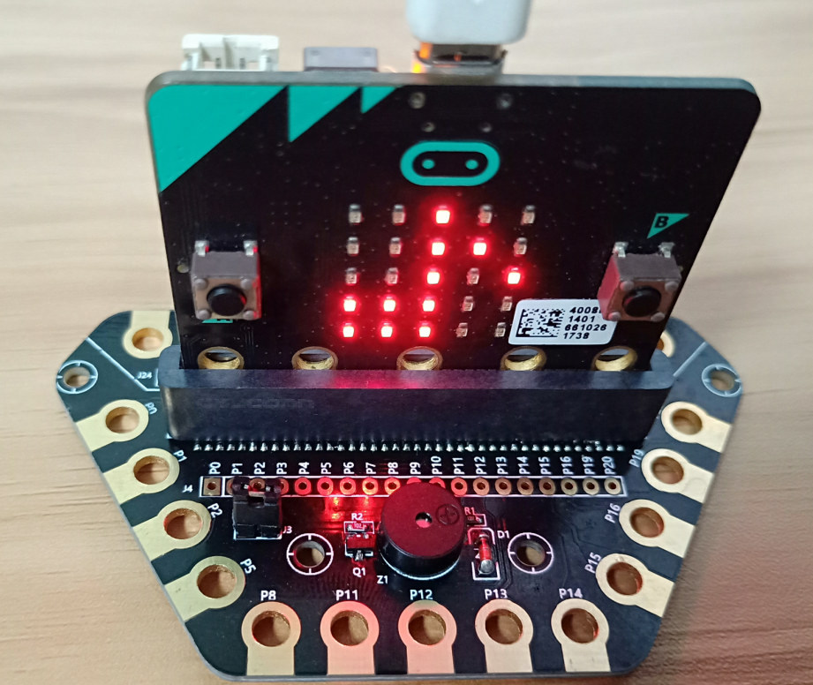

Note: There is a headphone jack on the expansion board that can be used to plug in headphones. The buzzer has no sound when the jumper switch is removed.

